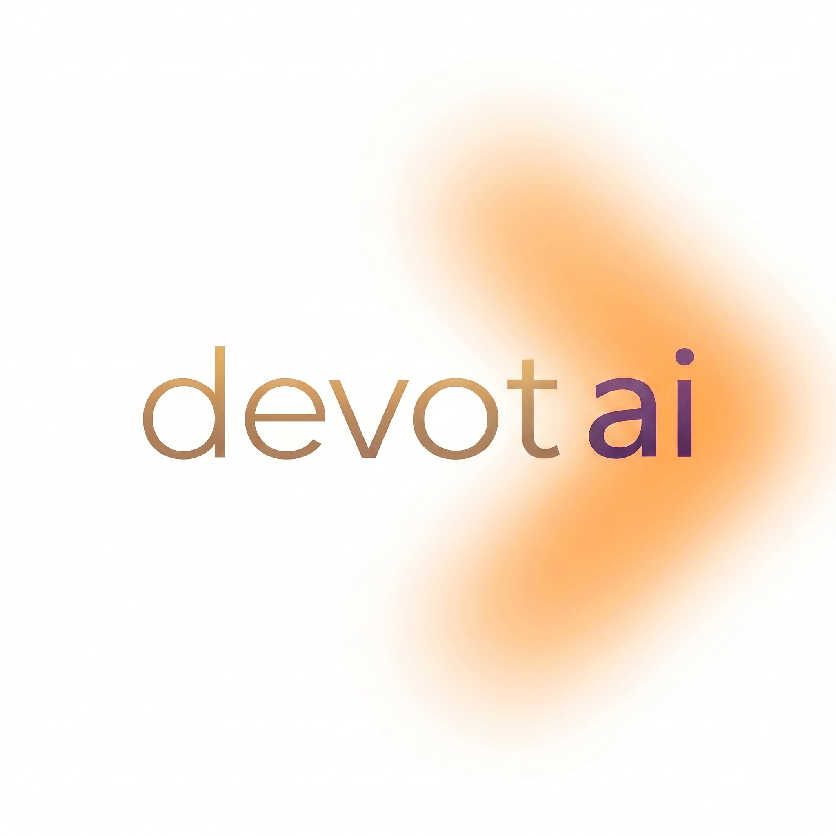
Job Description: Digital Marketing Intern (Full-Time, 6 Months)
Company: Devot AI Pvt. Ltd.
Location: Remote
Position Type: Internship (Full-Time)
Duration: 6 Months

About Devot AI Pvt. Ltd
Devot AI Pvt. Ltd is an AI startup focused on building intelligent, user-centric products. We work at the intersection of data, machine learning, and modern software development to solve real business problems. As a startup, we value ownership, adaptability and a hands-on mindset over rigid role boundaries.
Role Overview
We are looking for a proactive and self-driven Digital Marketing Intern to support our marketing and business development initiatives. The role involves creating marketing assets, assisting with lead generation, preparing sales and portfolio materials, conducting market research, and coordinating with clients and internal teams. This is an ideal opportunity for someone who enjoys working in a fast-paced startup environment, is eager to learn, and is comfortable taking ownership of diverse responsibilities while leveraging AI tools to improve productivity.
Key Responsibilities
- Assist in creating ad creatives and marketing assets (images, videos, banners, presentations, etc.).
- Support the creation and maintenance of company portfolios, case studies, and marketing collateral.
- Assist with social media content planning and publishing.
- Help prepare sales and marketing materials such as pitch decks, proposals, brochures, and one-pagers.
- Conduct basic market and competitor research.
- Coordinate with the design and AI teams to create marketing campaigns.
- Track campaign performance and prepare basic reports.
- Support lead generation and other marketing initiatives as required.
- Be active on our sales channels, identify potential project opportunities, assist with initial client communication, and coordinate between clients and the development team to ensure smooth pre-sales interactions and follow-ups.
Skills & Requirements
- Pursuing or recently completed a degree in Marketing, Business, Mass Communication, or a related field.
- Basic understanding of digital marketing concepts (SEO, SEM, social media, email marketing, and paid advertising).
- Familiarity with design tools such as Canva; knowledge of Figma or Adobe Creative Suite and video editing skill is a plus.
- Good written and verbal communication skills.
- Basic knowledge of Meta Ads, Google Ads, or other social media marketing is a plus.
- Comfortable using AI tools such as ChatGPT, Gemini, or Claude for content creation and research.
- Creative mindset with attention to detail.
- Ability to learn quickly and work independently.
- Startup mindset with a willingness to adapt to changing priorities, flexible working hours when required, and the ability to take on diverse responsibilities across marketing, sales, and business operations.
- Candidates should be comfortable leveraging AI tools to improve productivity, create marketing content, assist with ad creatives, and support sales collateral.
Nice to Have
- Experience managing social media pages.
- Portfolio of marketing creatives or campaigns.
- Understanding of B2B marketing and lead generation.

Why Join Devot AI?
- Work closely with an AI-focused startup and gain hands-on experience across digital marketing, sales, and business development.
- Opportunity to work on real client projects, marketing campaigns, lead generation activities, and portfolio-building initiatives.
- Learn and leverage modern AI tools to improve marketing workflows, content creation, and business processes.
- Gain exposure to the complete business lifecycle, from identifying opportunities and client communication to coordinating with technical teams for project execution.
- Be part of a fast-growing environment where your ideas, creativity, and contributions directly impact business growth.
- Opportunity for a full-time role based on performance and business needs.
Please include links to(if any):
- Portfolio or samples of marketing work (ad creatives, social media posts, content, presentations, etc.).
- Any digital marketing, lead generation, client outreach, or sales-related experience.
- Links to relevant projects, campaigns, or personal portfolios (if available).
- Experience with marketing tools, design tools, or AI tools.

