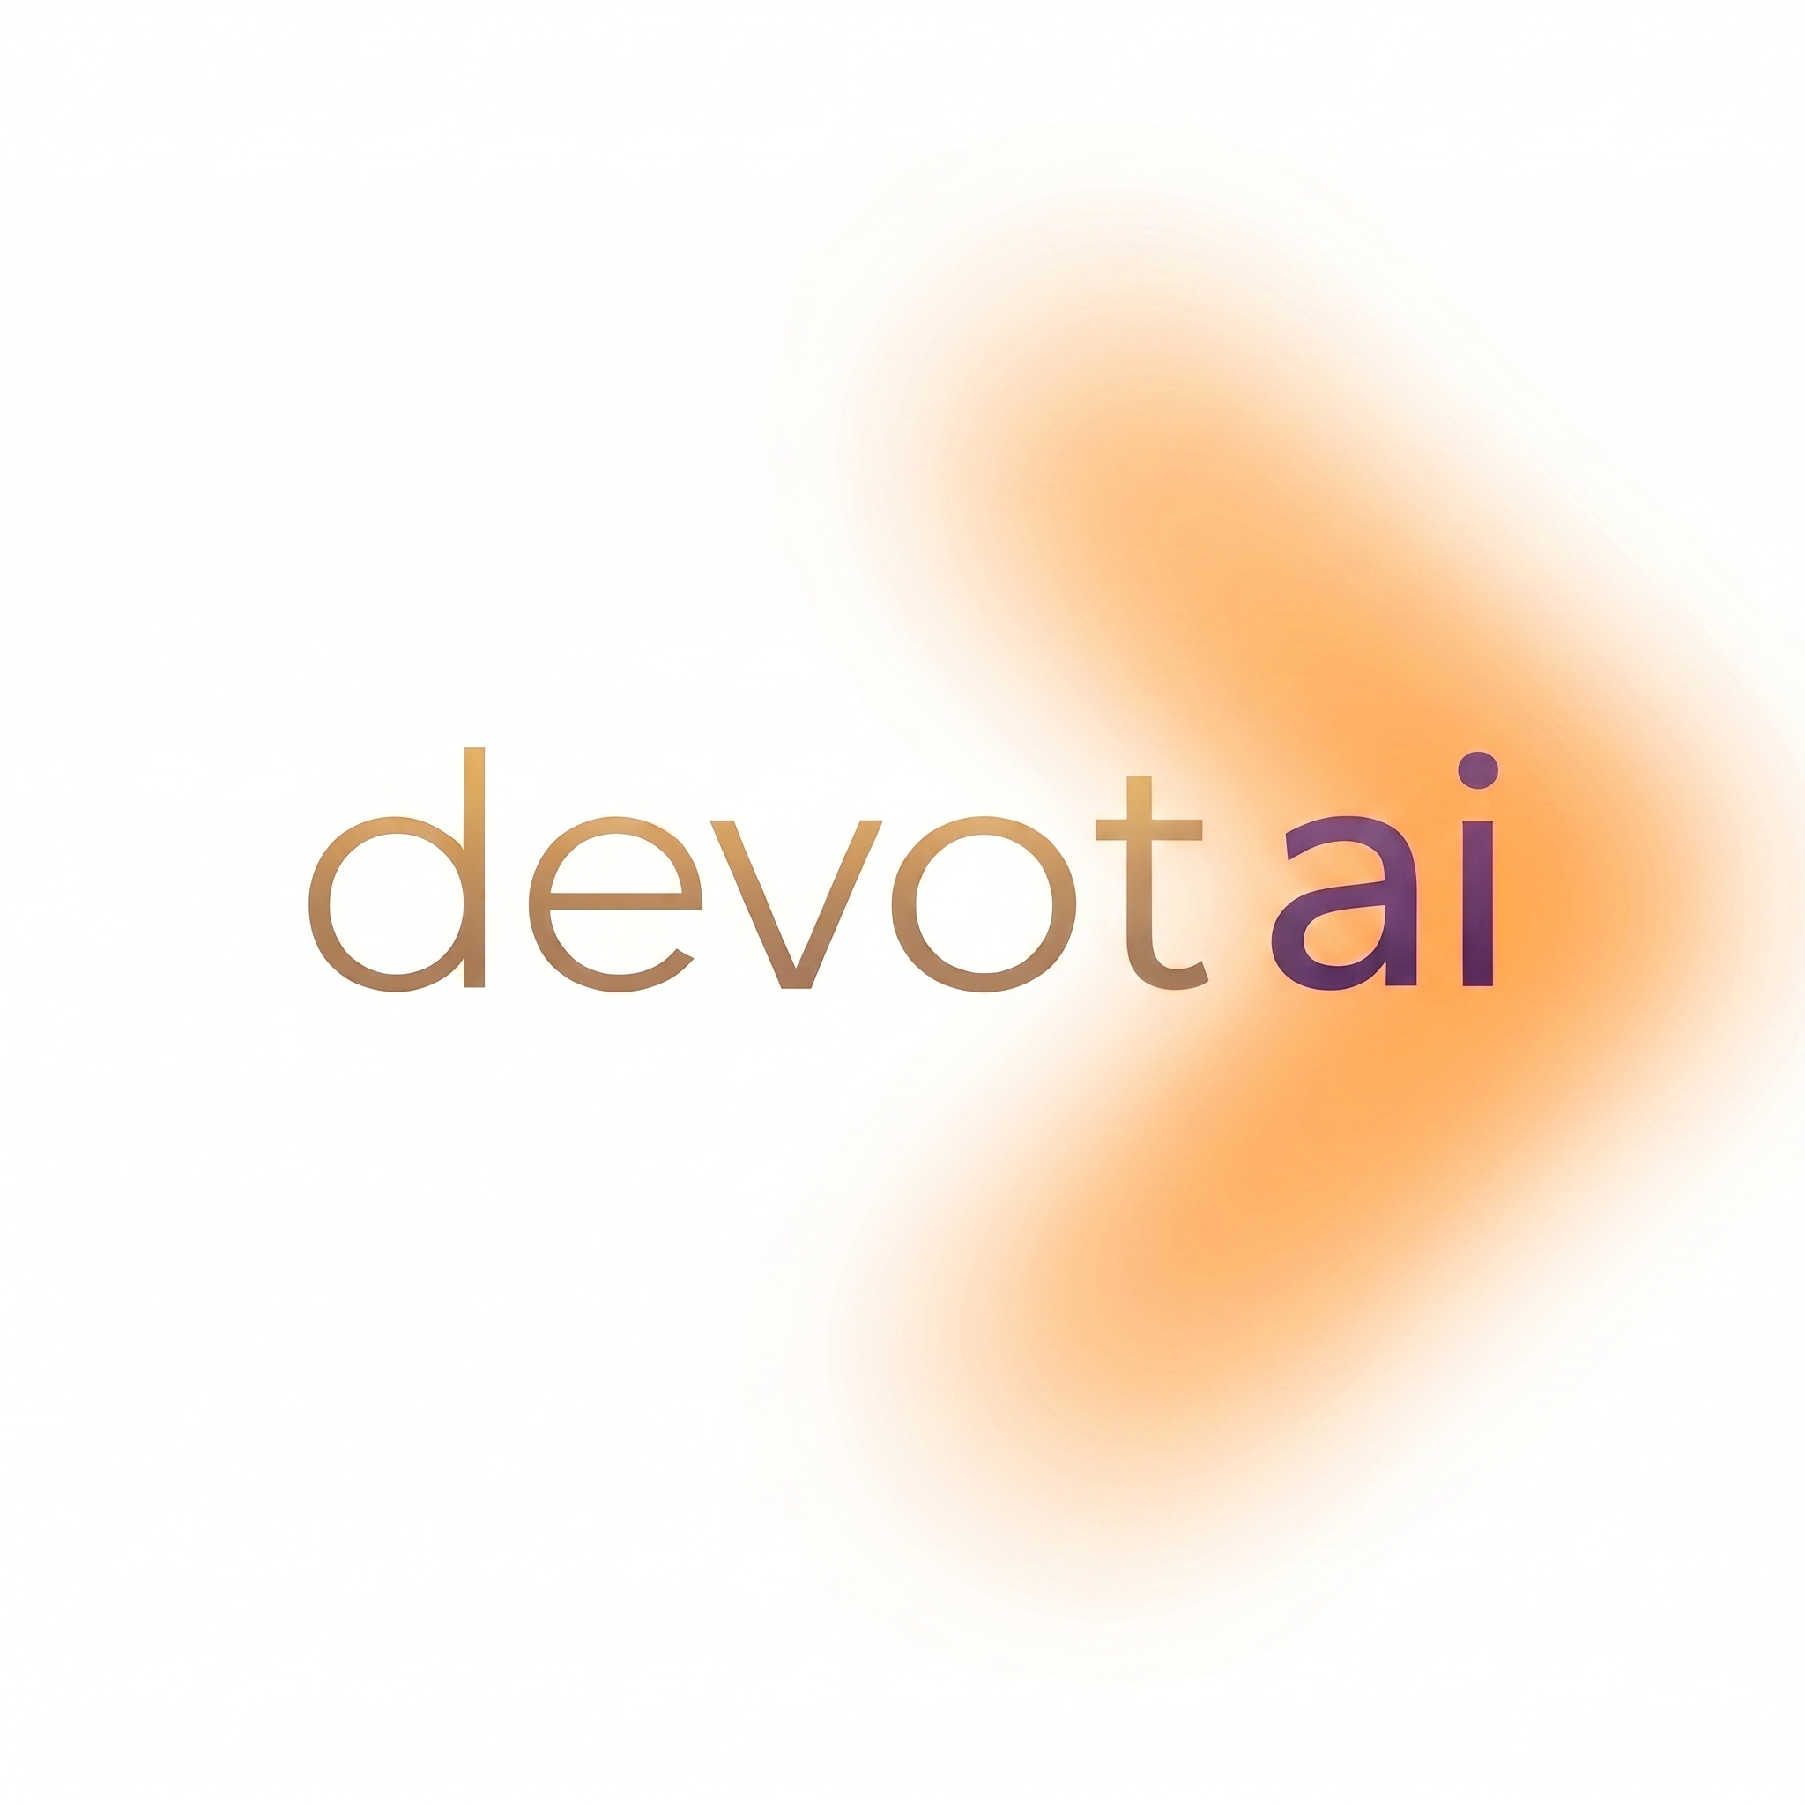
Job Description: Full Stack Data Scientist (Full-Time)
Company: Devot AI Pvt. Ltd.
Location: Remote
Position Type: Full-Time
Experience: 0.5 - 1 Year

About Devot AI Pvt. Ltd
Devot AI Pvt. Ltd is an AI startup focused on building intelligent, user-centric products. We work at the intersection of data, machine learning, and modern software development to solve real business problems. As a startup, we value ownership, adaptability and a hands-on mindset over rigid role boundaries.

Role Overview
We are looking for a Full Stack Data Scientist who can build complete products - not just models or notebooks. This is someone who can take a business problem, figure out what needs to be built, and ship it end-to-end: the data layer, the backend, the frontend, the deployment, and the iteration loop after launch.
Your core strength is in data science, but the role is product builder first. On any given day, you might be building a client-facing web app, wiring up a data pipeline, training a model, designing an internal tool, or automating a workflow. What stays constant is this: you own what you build, from first commit to production.
This is a startup-style role. You will work closely with founders, engineers, and product teams on real, production-facing systems. Beyond technical work, you will also be expected to contribute to client communication and day-to-day business support as needed.

Key Responsibilities
End-to-End Product Development
- Build, and ship complete products - web apps, dashboards, internal tools, automation pipelines, AI-powered features, or whatever the business requires.
- Handle the full stack: frontend (React/Next.js), backend (Python/Node.js, REST APIs), databases, and cloud deployment.
- Apply data science and ML where it adds real value to the product - not as an afterthought or a checkbox.
- Own the entire lifecycle: scoping, development, testing, deployment, monitoring, and iteration.

Data Science & Technical Development
- Analyze, clean, and preprocess structured and unstructured data.
- Build, evaluate, and iterate on ML models and data-driven solutions as needed.
- Work on AI-driven features, including traditional ML and GenAI-based workflows where applicable.
- Design and maintain data pipelines, automation scripts, and performance monitoring systems.

Cross-Functional Contributions
- Collaborate with backend, frontend, and product teams seamlessly - you are not siloed into one function.
- Contribute to backend logic, APIs, dashboards, UI integrations, DevOps tasks, or anything the project demands.
- Support deployment and maintenance of products in production environments.
- Adapt quickly to changing project needs typical of a startup environment.

Client Communication & Business Support
- Monitor and respond to incoming client inquiries and messages across business platforms in a timely and professional manner.
- Assist in understanding client requirements, documenting them clearly, and coordinating with the team.
- Help prepare project proposals and client-facing documentation under the guidance of the manager.
- Follow up with prospects and clients, maintaining clear and proactive communication throughout.

Learning & Ownership
- Take ownership of tasks and products end-to-end rather than working on isolated assignments.
- Research new tools, frameworks, and approaches relevant to the company's roadmap.
- Use Git for version control and document work, assumptions, and learnings clearly.

Required Skills & Qualifications
Core Technical Skills
- Strong proficiency in Python.
- Solid understanding of Machine Learning and Data Science fundamentals with hands-on project experience.
- Working knowledge of frontend development - React/Next.js, HTML, CSS, JavaScript.
- Proficiency in backend development - REST APIs, server-side logic, authentication, and database design.
- Hands-on experience with SQL, databases (PostgreSQL/MongoDB), and data pipelines.
- Familiarity with cloud platforms (AWS/GCP/Azure) and deployment workflows (Docker, CI/CD basics).
- Proficiency with Git and collaborative development workflows.

Communication & Client-Facing Skills
- Good written and verbal communication. Comfortable drafting professional messages, proposals, and documentation if required.
- Ability to understand client requirements and translate them into clear internal briefs.
- Proactive attitude with the confidence to interact with clients and prospects.

Important Notes
- This is a full-time role requiring complete availability.
- Not suitable for candidates seeking narrowly defined, single-domain roles.
- The role involves a mix of product development, data science, and client-facing / business support activities depending on project needs.

Why Join Devot AI?
- Build and ship real products - not just prototypes or Jupyter notebooks.
- Work across the full stack: frontend, backend, data, ML, deployment.
- Gain exposure to client interaction, product thinking, and business operations.
- Learn how products are built and sold end-to-end in a startup environment.
- Opportunity for a long-term role based on performance and business needs.

Please include links to (if any):
- GitHub repositories
- Deployed products, live apps, or demos
- Projects, experiments, or portfolios demonstrating hands-on, end-to-end work

