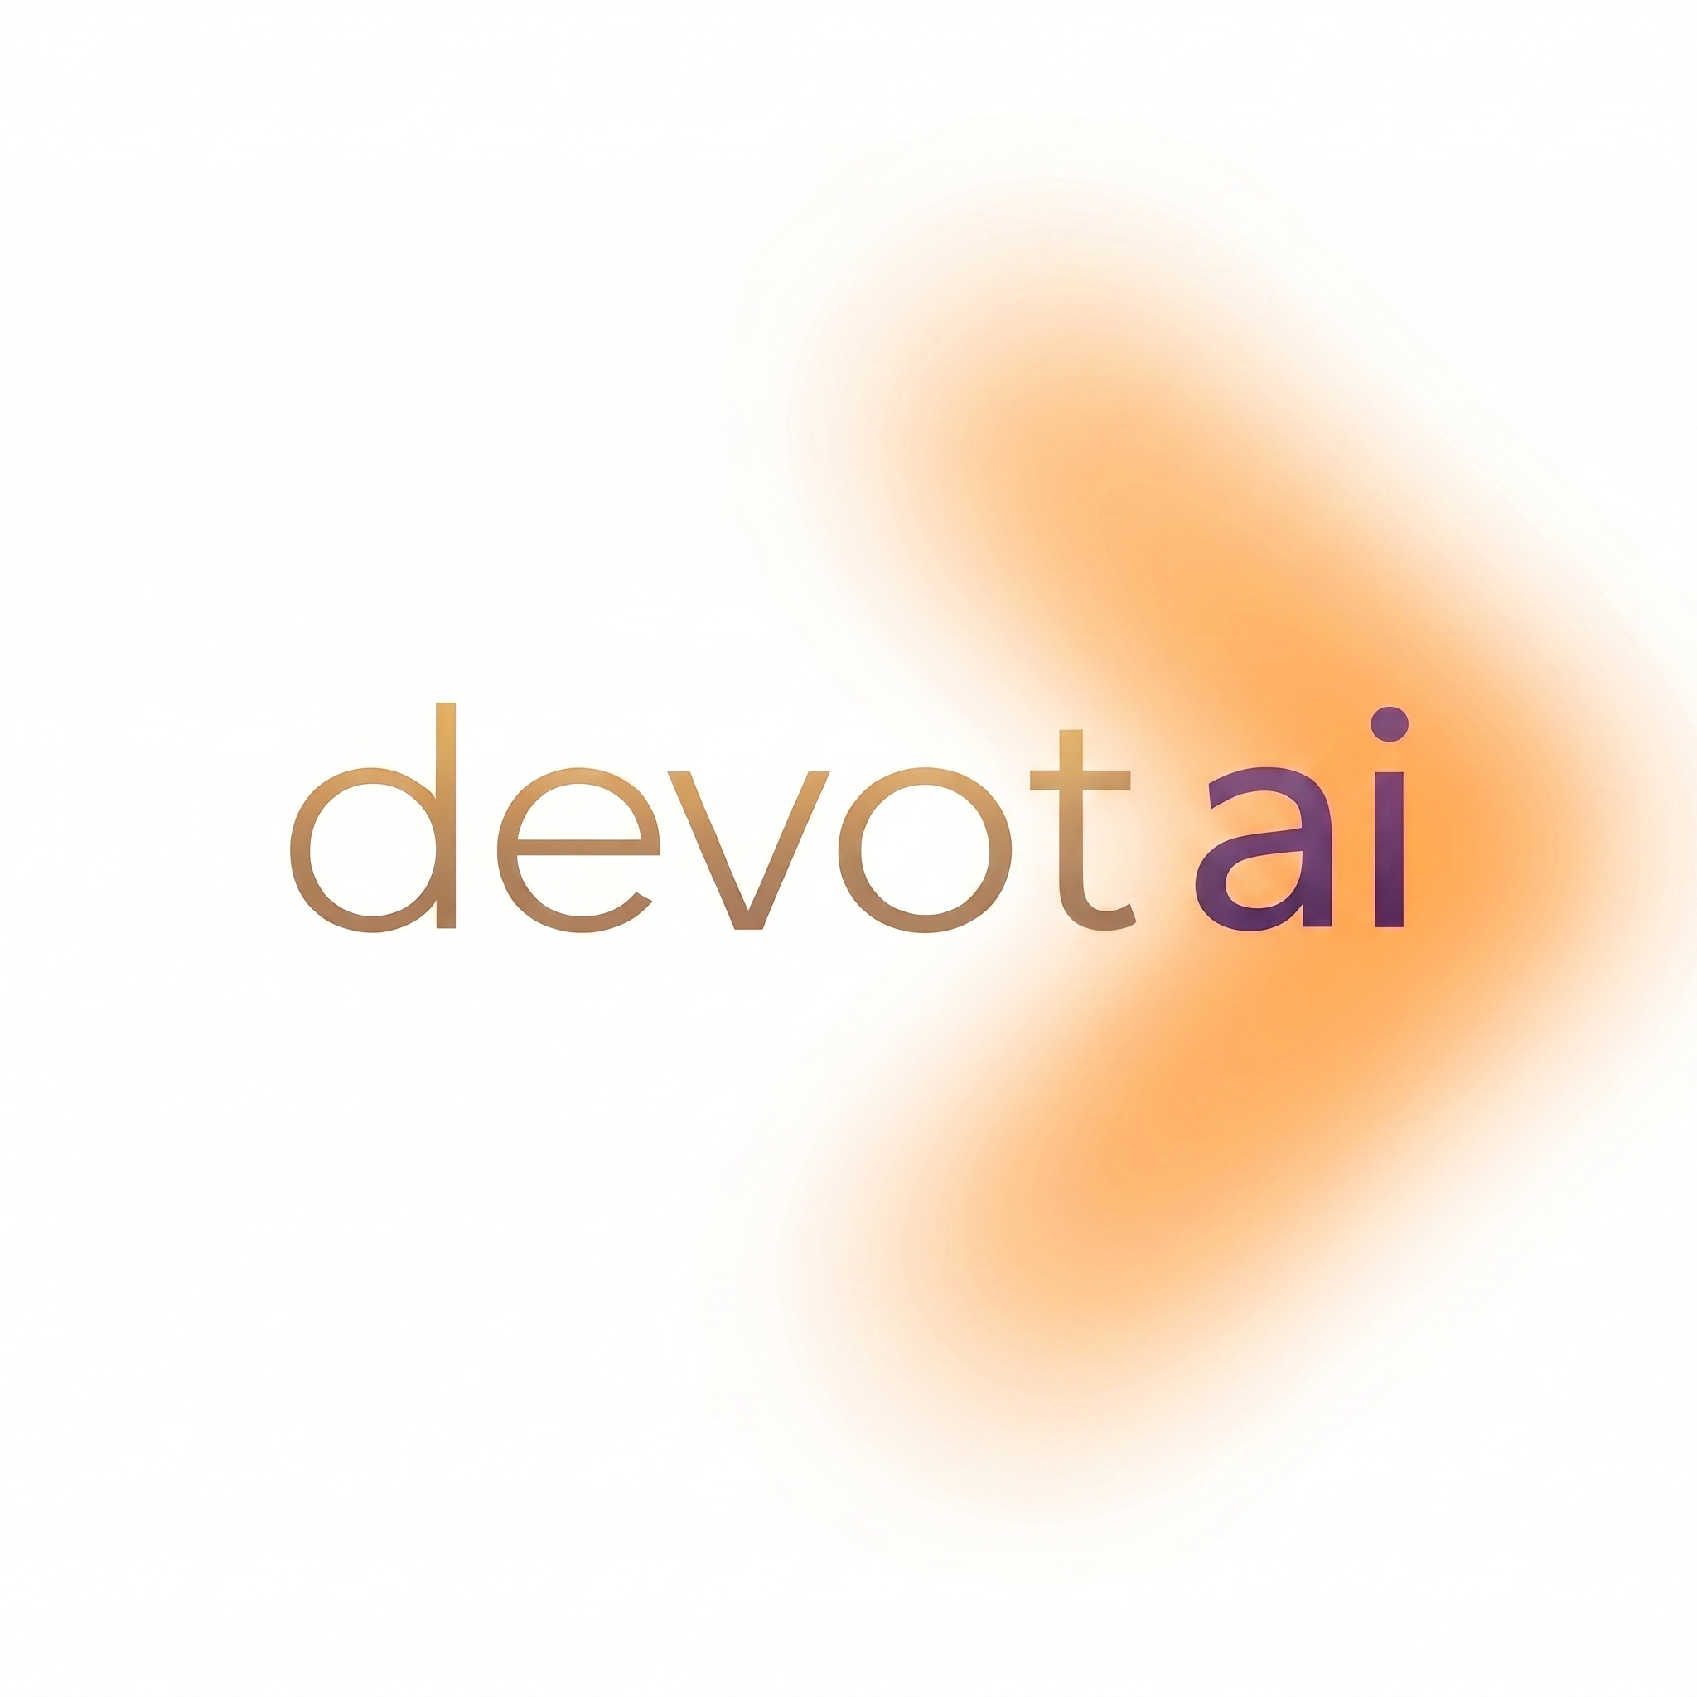
Job Description: Data Science / AI Intern (Full-Time, 6 Months)
Company: Devot AI Pvt. Ltd.
Location: Remote
Position Type: Internship (Full-Time)
Duration: 6 Months

About Devot AI Pvt. Ltd
Devot AI Pvt. Ltd is an AI startup focused on building intelligent, user-centric products. We work at the intersection of data, machine learning, and modern software development to solve real business problems. As a startup, we value ownership, adaptability and a hands-on mindset over rigid role boundaries.
Role Overview
We are looking for a full-time Data Science / AI Intern who is technically strong, a quick learner, and comfortable working across different areas as the business requires. While your core strength should be in data science and technology, this is a startup-style role - not a narrowly scoped academic internship. You will be expected to contribute wherever the team needs you, including technical development, client communication, requirement analysis, proposal writing, and day-to-day business support if required alongside your core work.
You will work closely with founders, engineers, and product teams on real production-facing systems.
.Key Responsibilities
Data Science & Technical Development
- Analyze, clean and preprocess structured and unstructured data.
- Build, evaluate and iterate on ML models and data-driven solutions.
- Work on AI-driven features, including traditional ML and GenAI-based workflows as needed.
- Assist in model integration, experimentation, and performance monitoring.
Cross-Functional Contributions
- Collaborate with backend, frontend and product teams as needed.
- Contribute to backend logic, APIs, automation scripts, dashboards or UI integrations when required.
- Support deployment of ML/AI components into production environments.
- Adapt quickly to changing project needs typical of a startup environment.
Client Communication & Business Support
- Monitor and respond to incoming client inquiries and messages across business platforms in a timely and professional manner.
- Assist in understanding client requirements, documenting them clearly, and coordinating with the team for scoping and estimation.
- Help prepare project proposals and client-facing documentation under the guidance of the manager.
- Follow up with prospects and clients, maintaining clear and proactive communication throughout.
Learning & Ownership
- Take ownership of tasks end-to-end rather than working on isolated assignments.
- Research new tools, frameworks and approaches relevant to the company’s roadmap.
- Use Git for version control and document work, assumptions and learnings clearly.

Required Skills & Qualifications
Core Technical Skills
- Strong foundation in Python.
- Solid understanding of Machine Learning and Data Science fundamentals.
- Hands-on experience with libraries such as NumPy, Pandas, Scikit-learn (TensorFlow/PyTorch is a plus).
- Familiarity with SQL, databases, and data pipelines.
- Familiarity with frontend concepts (React/JS/HTML/CSS) and dashboards/visualizations (Streamlit, Plotly, etc.).
- Familiarity with Git.
Communication & Client-Facing Skills
- Good written and verbal communication. Comfortable drafting professional messages, proposals, and documentation if required.
- Ability to understand client requirements and translate them into clear internal briefs.
- Proactive attitude with the confidence to interact with clients and prospects.
Mindset
- Comfortable working beyond a single domain when required.
- Willingness to learn new tools, frameworks or technologies quickly.
- Strong problem-solving and debugging ability.
- High ownership, adaptability, and startup mindset.

Important Notes
- This is a full-time internship requiring complete availability for 6 months.
- Not suitable for candidates seeking narrowly defined roles or limited responsibilities.
- The role involves a mix of technical work and client-facing / business support activities depending on project needs.
- Opportunity for a full-time role based on performance and business needs.

Why Join Devot AI?
- Work on real, production-grade systems - not just academic exercises.
- Gain exposure across technical development, client interaction, and business operations.
- Learn how products are built and sold end-to-end in a startup environment.
- Opportunity for a full-time role based on performance and business needs.
Please include links to(if any):
- GitHub repositories
- Projects, experiments, or portfolios demonstrating hands-on work

